Coding Challenges – Pet Pals, The Pet Adoption Platform

**Karthikeyan M**

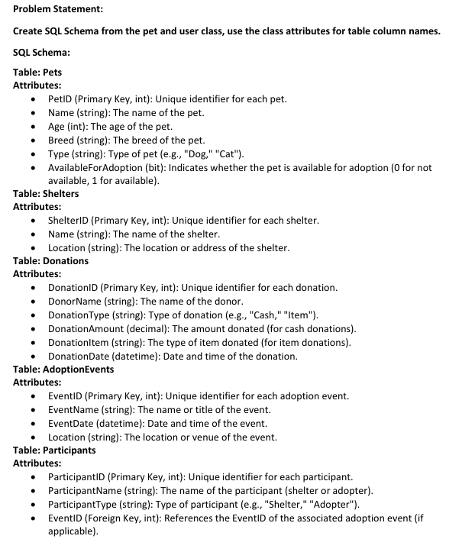

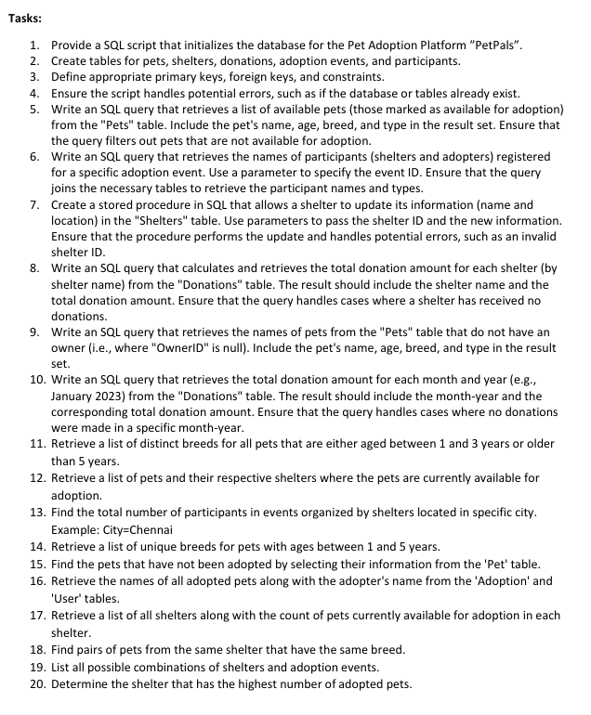

**Queries:**

-- 1

USE petpals;

-- 2,3,4 Qns.

CREATE TABLE Pets (

PetID INT PRIMARY KEY AUTO_INCREMENT,

name VARCHAR(255) NOT NULL,

Age INT,

Breed VARCHAR(255),

Type VARCHAR(50),

AvailableForAdoption BIT DEFAULT 1

);

CREATE TABLE Shelters (

ShelterID INT PRIMARY KEY AUTO_INCREMENT,

name VARCHAR(255) NOT NULL,

Location VARCHAR(255) NOT NULL

);

CREATE TABLE Donations (

DonationID INT PRIMARY KEY AUTO_INCREMENT,

Donorname VARCHAR(255) NOT NULL,

DonationType VARCHAR(50),

DonationAmount DECIMAL(10,2),

DonationItem VARCHAR(255),

DonationDate DATETIME DEFAULT CURRENT_TIMESTAMP

);

CREATE TABLE AdoptionEvents (

EventID INT PRIMARY KEY AUTO_INCREMENT,

Eventname VARCHAR(255) NOT NULL,

EventDate DATETIME NOT NULL,

Location VARCHAR(255) NOT NULL

);

CREATE TABLE Participants (

ParticipantID INT PRIMARY KEY AUTO_INCREMENT,

Participantname VARCHAR(255) NOT NULL,

ParticipantType ENUM('Shelter', 'Adopter') NOT NULL,

EventID INT,

FOREIGN KEY (EventID) REFERENCES AdoptionEvents(EventID)

);

-- 5

INSERT INTO Pets (name, Age, Breed, Type, AvailableForAdoption) VALUES

('Rani', 5, 'Indian Spitz', 'Dog', 1),

('Meera', 7, 'Siamese', 'Cat', 0),

('Kabir', 4, 'Golden Retriever', 'Dog', 1);

SELECT * FROM Pets WHERE AvailableForAdoption=1;

INSERT INTO Shelters (name, Location) VALUES

('Hearts Animal Shelter', 'Kolkata'),

('Blue Cross Society', 'Kochi'),

('PAWS India', 'Bangalore');

INSERT INTO Donations (Donorname, DonationType, DonationAmount, DonationItem, DonationDate) VALUES

('Priya Sharma', 'Cash', 7500.00, NULL, NOW()),

('Arjun Singh', 'Item', NULL, 'Cat Litter', NOW()),

('Anika Patel', 'Cash', 4200.00, NULL, NOW());

INSERT INTO AdoptionEvents (Eventname, EventDate, Location) VALUES

('Annual Pet Adoption Fair', '2024-11-12 09:00:00', 'Mumbai'),

('Community Animal Day', '2024-12-05 10:30:00', 'Hyderabad'),

('Pawsitive Connections', '2025-01-15 11:00:00', 'Kochi');

INSERT INTO Participants (ParticipantName, ParticipantType, EventID) VALUES

('Vikram Aditya', 'Adopter', 3),

('Kriti Sharma', 'Adopter', 1),

('Praveen', 'Shelter', 2);

-- 6 Considering EventID = 2

SELECT Participants.ParticipantName, Participants.ParticipantType

FROM Participants

JOIN AdoptionEvents ON Participants.EventID = AdoptionEvents.EventID

WHERE Participants.EventID = 2;

-- 7

UPDATE shelters

SET NAME = 'new puppy takecare stop', location = 'Madurai'

WHERE shelterid = 3;

SELECT * FROM Shelters;

-- 8

SELECT shelters.name as NAMES, COALESCE(sum(donations.donationamount), 0) as Donation_Received

FROM shelters

LEFT JOIN donations on shelters.shelterid = donations.donationid

GROUP BY shelters.name;

-- 11

SELECT DISTINCT Breed

FROM Pets

WHERE (Age BETWEEN 1 AND 3) OR (Age > 5);

-- 12

SELECT Pets.name AS PetName, Shelters.name AS ShelterName

FROM Pets

JOIN Shelters ON Pets.AvailableForAdoption = 1;

-- 13 as there is no chennai in input inserted so changed city to kochi

SELECT COUNT(*) AS Total

FROM Participants

JOIN AdoptionEvents ON Participants.EventID = AdoptionEvents.EventID

WHERE AdoptionEvents.Location = 'Kochi';

-- 14

SELECT DISTINCT Breed FROM Pets WHERE Age BETWEEN 1 AND 5;

-- 15

SELECT * FROM Pets WHERE AvailableForAdoption = 0;

-- 17

SELECT Shelters.name AS SName, COUNT(Pets.PetID) AS Pets

FROM Shelters

LEFT JOIN Pets ON Pets.AvailableForAdoption = 1

GROUP BY Shelters.name;

-- 18

SELECT p1.name AS Pet1, p2.name AS Pet2, p1.Breed, s.name AS ShelterName

FROM Pets p1

JOIN Pets p2 ON p1.Breed = p2.Breed AND p1.PetID < p2.PetID

JOIN Shelters s ON p1.AvailableForAdoption = 1 AND p2.AvailableForAdoption = 1;

-- 19

SELECT s.name AS ShelterName, e.Eventname AS EventName

FROM Shelters s

CROSS JOIN AdoptionEvents e;

-- 20

SELECT COUNT(*) AS TotalAdoptedPets

FROM Pets

WHERE AvailableForAdoption = 0;

**OUTPUT:** 